23I0544

MUHAMMAD HAMMAD

BCS-3D

LAB 03

TASK 01:

INCLUDE Irvine32.inc

.data

value0 WORD ?

value1 SBYTE -11

.code

main PROC

movsx eax, value1

call Writeint

call Crlf

exit

main ENDP

END main

OUTPUT:

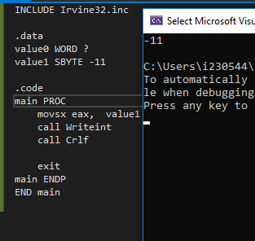

TAASK 02:

INCLUDE Irvine32.inc

.data

value0 SDWORD ?

.code

main PROC

mov value0, -2147483648

mov eax, value0

call Writeint

call Crlf

exit

main ENDP

END main

OUTPUT:

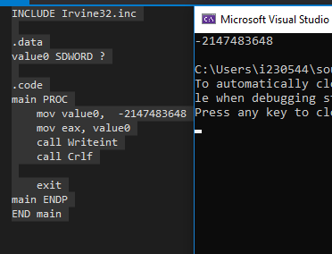

TASK 03:

INCLUDE Irvine32.inc

.data

value0 WORD 1111, 2222, 3333

.code

main PROC

movzx eax, value0

call Writeint

call Crlf

exit

main ENDP

END main

OUTPUT:

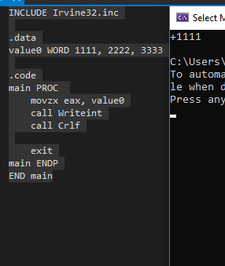

TASK 04:

INCLUDE Irvine32.inc

.data

color BYTE "Blue", 0

A WORD 12

B WORD 2

cC WORD 13

D WORD 8

E WORD 14

.code

main PROC

mov edx, OFFSET color

call WriteString

call Crlf

movzx eax, A

call WriteInt

call Crlf

movzx eax, B

call WriteInt

call Crlf

movzx eax, Cc

call WriteInt

call Crlf

movzx eax, D

call WriteInt

call Crlf

movzx eax, E

call WriteInt

call Crlf

exit

main ENDP

END main

TASK 05:

INCLUDE Irvine32.inc

.data

a BYTE 10h

b BYTE 11h

cc BYTE 30h

d BYTE 40h

.code

main PROC

mov eax, 0

mov ebx, 0

mov edx, 0

mov al, a

mov bl, b

add al, bl

movzx eax, al

mov al, a

add al, b

mov bl, a

sub bl, b

sub al, bl

add al, cc

add al, d

movzx edx, al

call WriteInt

call Crlf

exit

main ENDP

END main

OUTPUT:

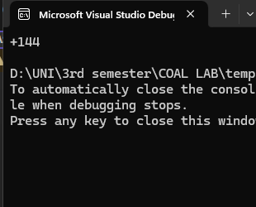

TASK 06:

INCLUDE Irvine32.inc

.data

a BYTE 00010001b

b BYTE 00010000b

cc BYTE 00110000b

d BYTE 01000000b

.code

main PROC

mov eax, 0

mov ebx, 0

mov edx, 0

mov al, a

mov bl, b

add al, bl

movzx eax, al

mov al, a

add al, b

mov bl, a

sub bl, b

sub al, bl

add al, cc

add al, dd

movzx edx, al

call WriteInt

call Crlf

exit

main ENDP

END main

TASK 07:

INCLUDE Irvine32.inc

.data

wArray WORD 1111, 2222, 3333

.code

main PROC

mov ax, wArray

movzx eax, ax

call WriteInt

call Crlf

mov ax, wArray[2]

movzx eax, ax

call WriteInt

call Crlf

mov ax, wArray[4]

movzx eax, ax

call WriteInt

call Crlf

exit

main ENDP

END main

TASK 08

INCLUDE Irvine32.inc

.data

dArray WORD 50 DUP (?)

.code

main PROC

; nothing in main because

;the question only asked for the initialization

exit

main ENDP

END main

TASK 09:

INCLUDE Irvine32.inc

.data

dArray BYTE 500 DUP ("TEST", )

.code

main PROC

mov edx, 0

mov edx, OFFSET dArray

call writeString

call Crlf

exit

main ENDP

END main

OUTPUT:

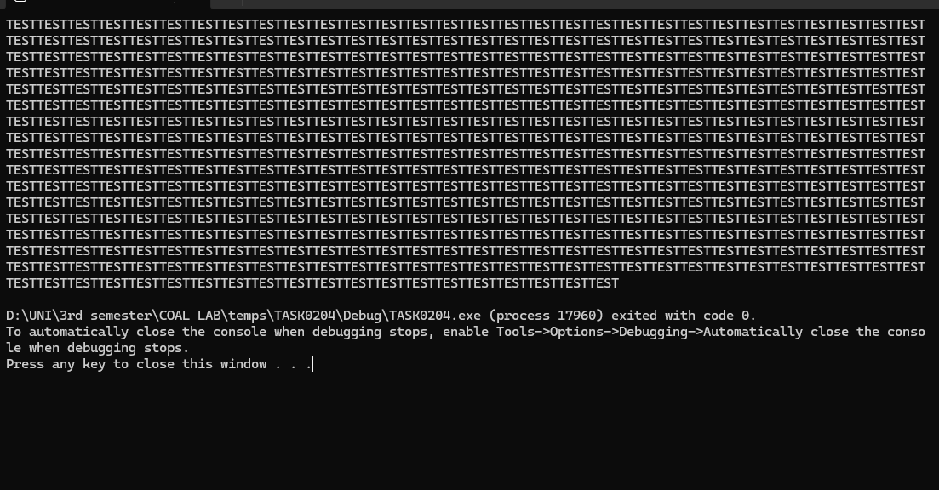

TASK 10:

INCLUDE Irvine32.inc

.data

bArray BYTE 20 DUP (0)

.code

main PROC

mov al, bArray

movzx eax , al

call WriteInt

call Crlf

exit

main ENDP

END main